**SWITCH CONTROLLER And MODULE CONTROLLER and INCLUDE CONTROLLER**

This Controller used to execute only one test script by having the test script name in SWITCH VALUE in Switch Controller.

Example:

PRE

Switch Controller

1-Link1 A/B-Test

2-link2-checkbox

3-link3-DrpDown

POST

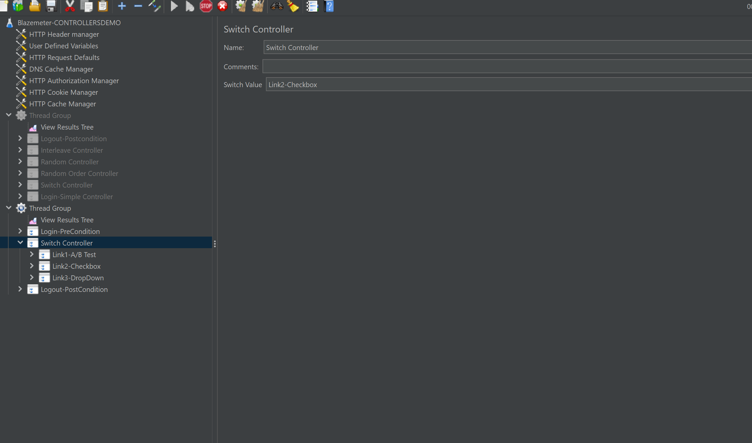

From Above..Having Switch value link3-checkbox…it executes

Pre—checkbox test link—post

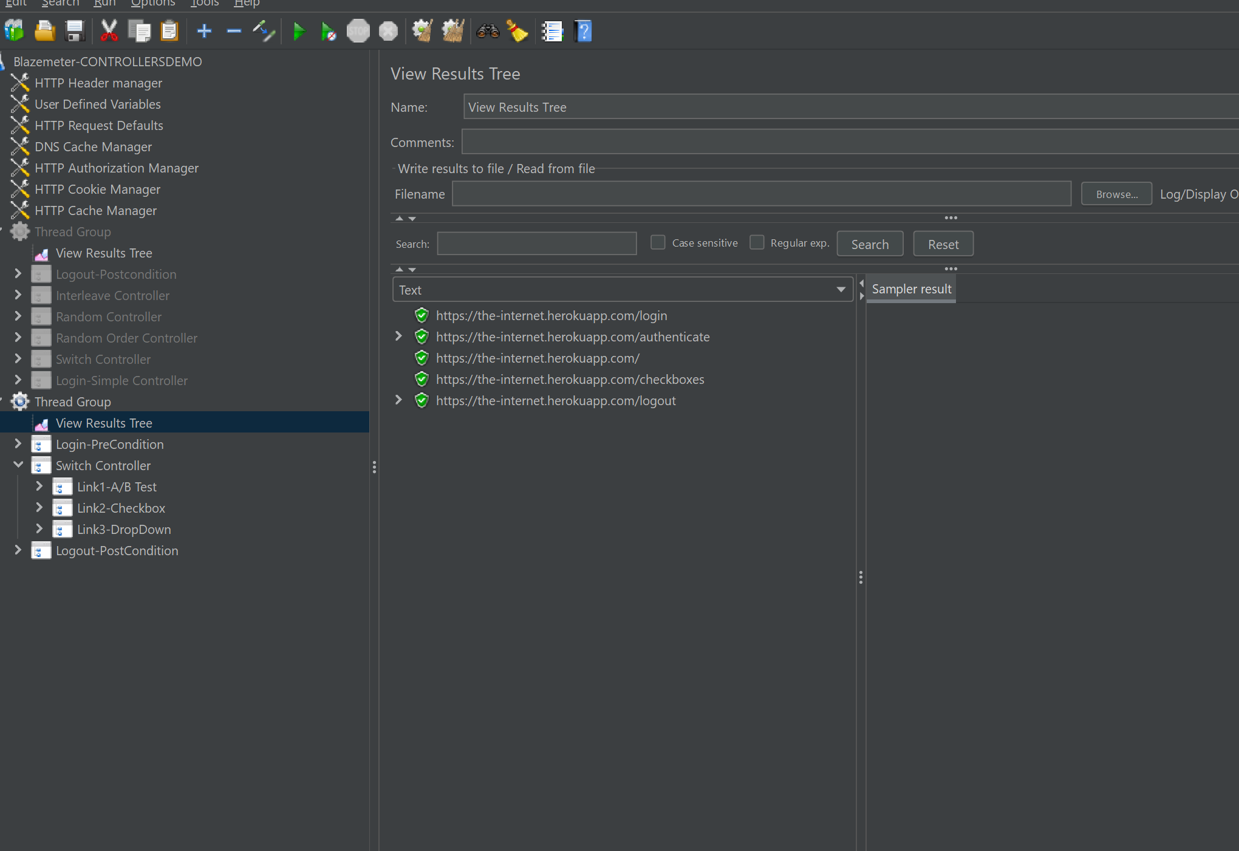

Demonstrating the module controller

* Right click on Test Plan-->Add-->Threads-->Thread Group. 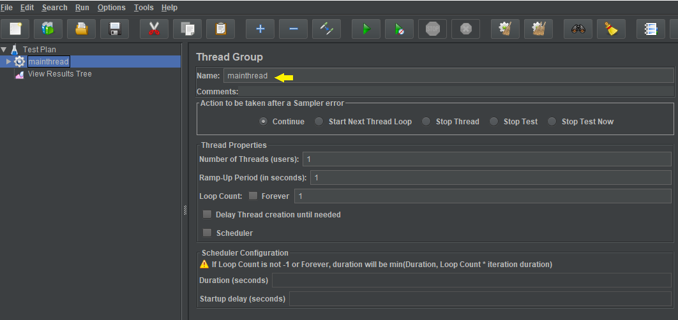
* Right click on Thread Group-->Add -->Logic Controller-->Module Controller.

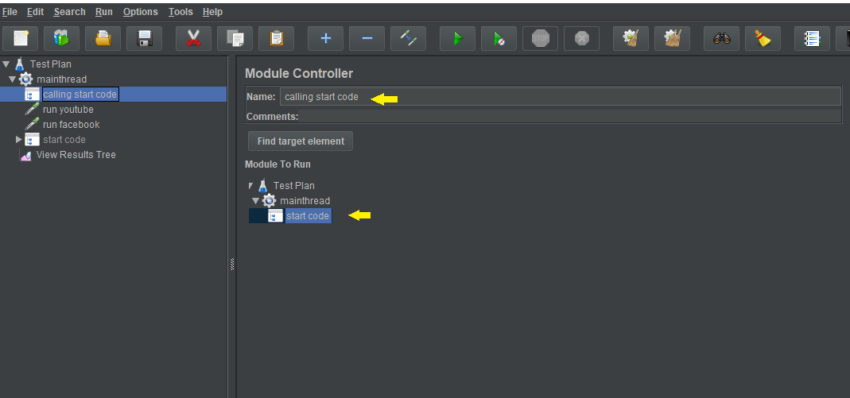

* Right click on Thread Group → Add → HTTP Request as shown below:

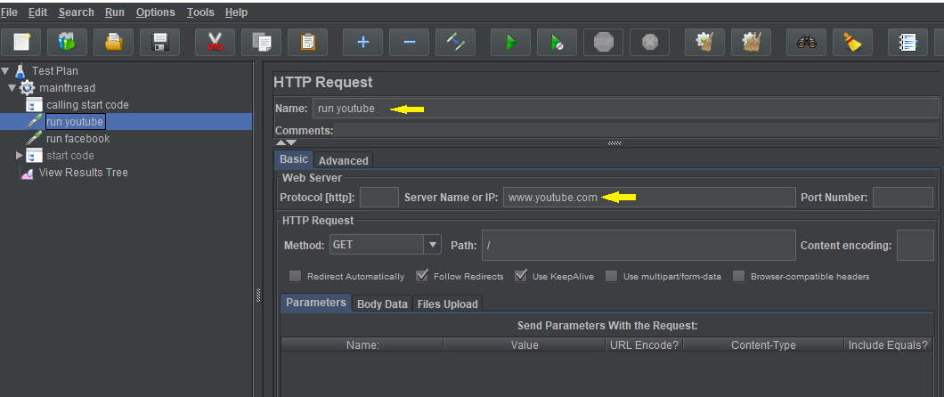

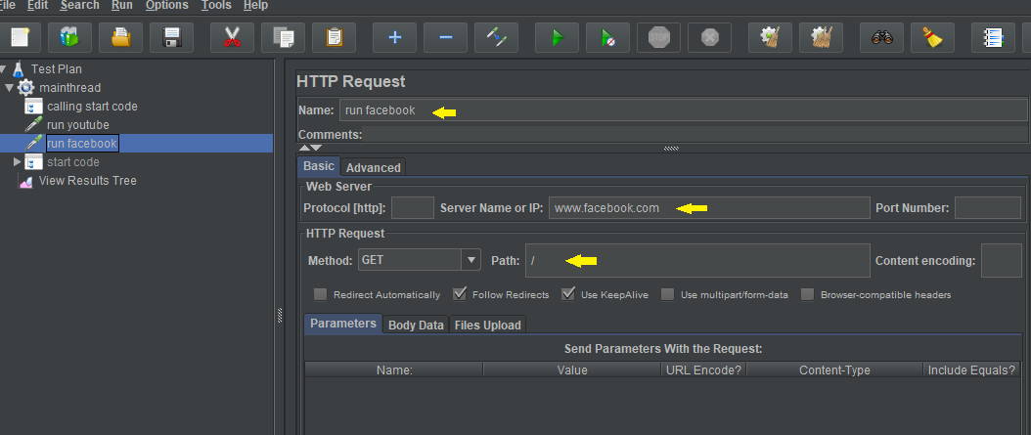

* Right click on Thread Group-->Add -->Logic Controller-->Simple Controller--> change name to **start code**. 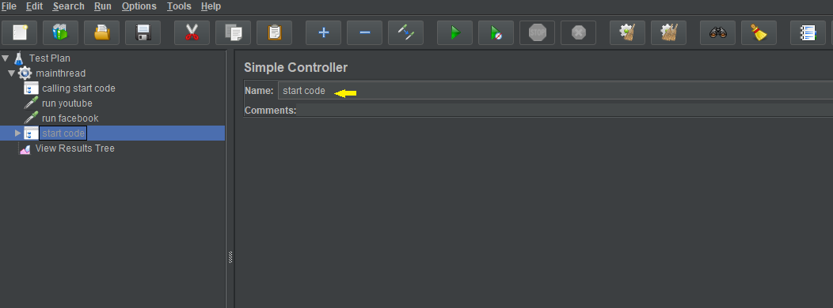
* Right click on start code -->Add-->Sampler-->Add two HTTP Requests. 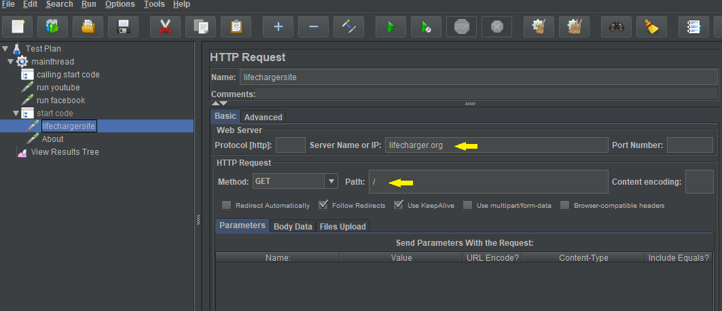 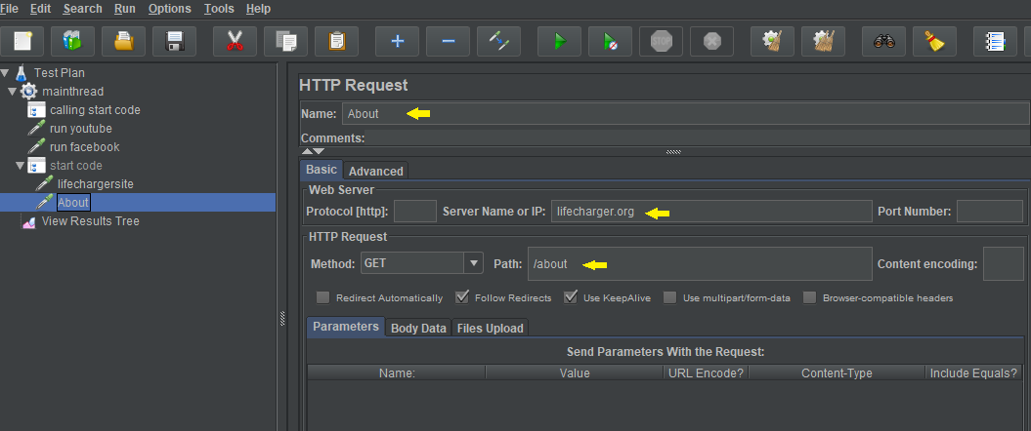
* Note: Now right click on start code and disable it. Click on the **Calling start code module controller.** Select **start code file** and run the **thread group**.
* Right click on Test Plan-->Add --> Listener-->View Result Tree-->Run.

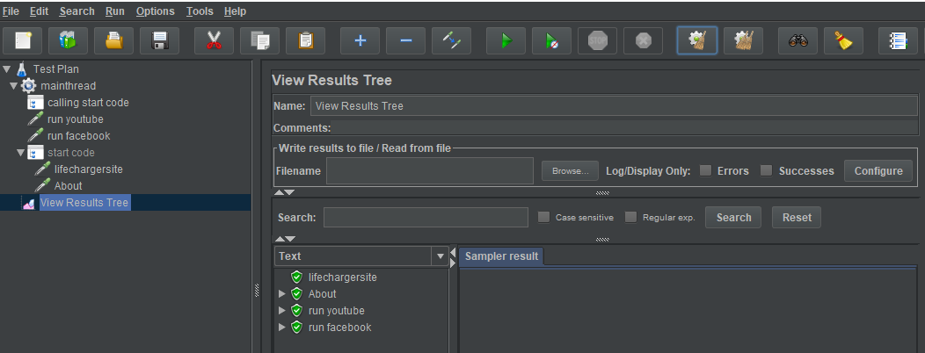

**Step 1.9.3:** Demonstrating include controller

* Right click on Test Plan-->Add-->Threads-->Thread Group.

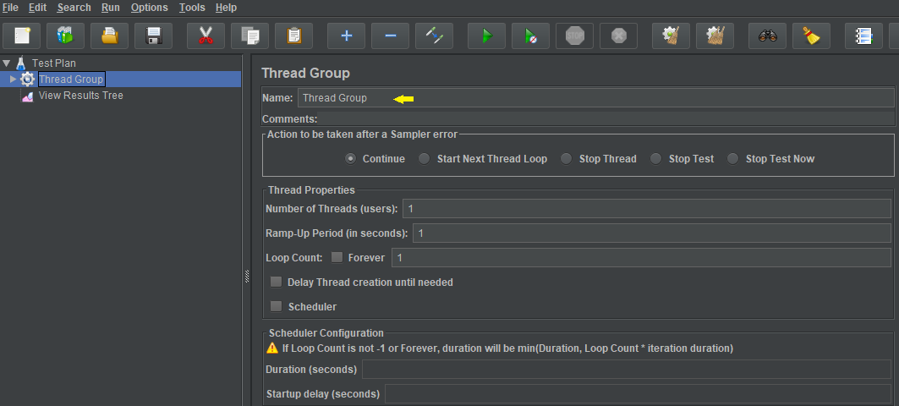

* Right click on Thread Group-->Add -->Sampler-->HTTP Request.

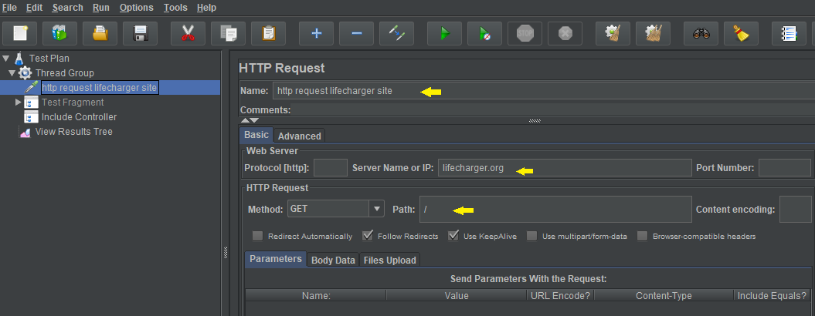

* Right click on Test Plan-->Add -->Test Fragment-->

-->Add-->HTTP Request under **Test Fragment**.

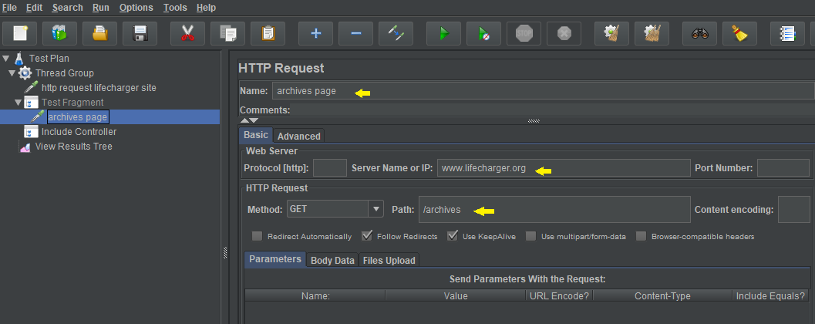

* Right click on Thread Group-->Add-->Logic Controller-->Include Controller-->load .jmx file in Include Controller.

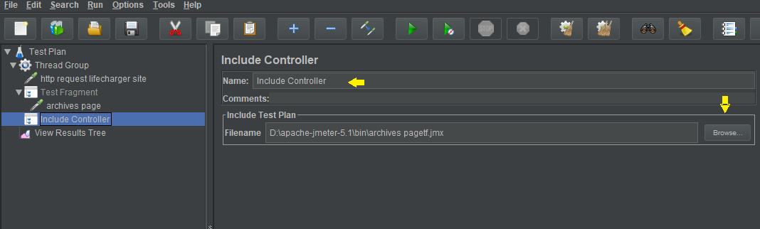

* Right click on Test Plan-->Add --> Listener-->View Result Tree-->Run. 